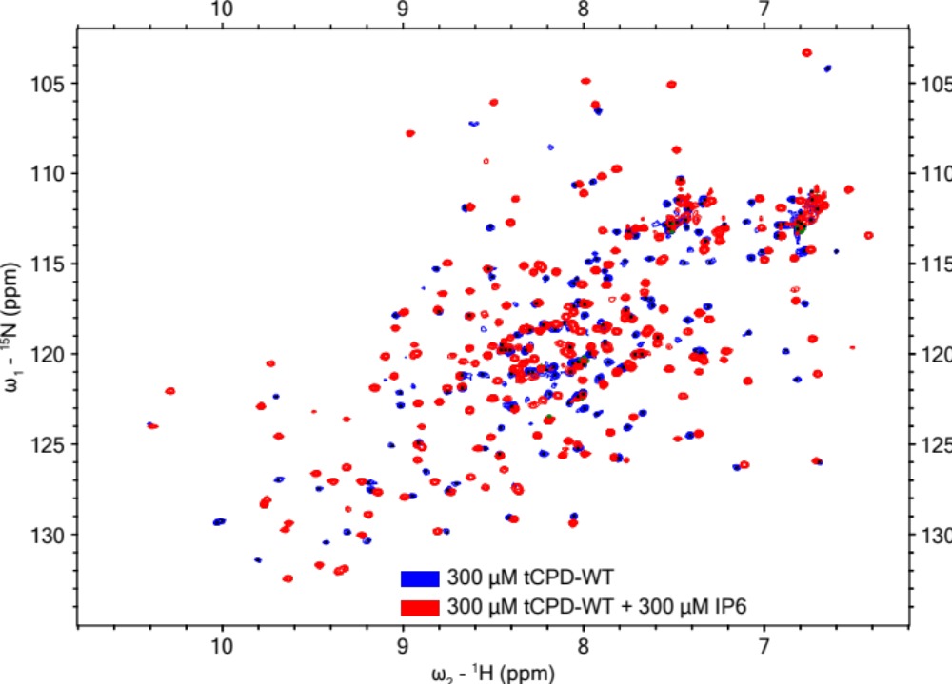
Figure 1. Two overlapping ¹H-¹⁵N-HSQC NMR spectra generated from 300 μM of tCPD-WT (peaks shown in blue) or 300 μM of tCPD-WT bound to a molar equivalent of IP6 (300 μM, peaks shown in red). The HSQC spectra for tCPD-WT showed the appearance of 153 well resolved peaks and upon binding to IP6 240 peaks were apparent.

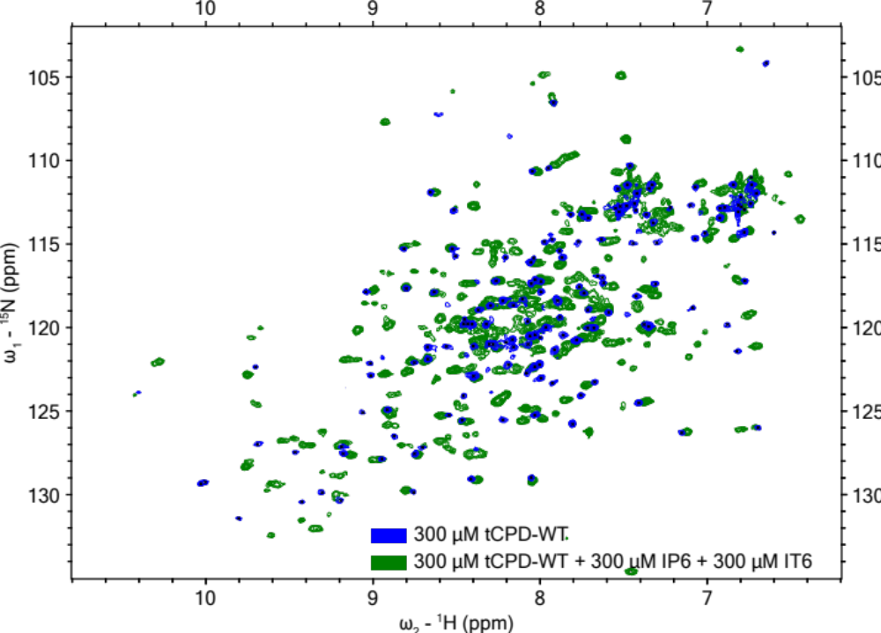
Figure 2. Two overlapping ¹H-¹⁵N-HSQC NMR spectra generated from 300 μM of tCPD-WT (peaks shown in blue) or 300 μM of tCPD-WT in the presence of a molar equivalent of IP6 and IT6 (300 μM each, peaks shown in green). The HSQC spectra for tCPD-WT showed the appearance of 153 well resolved peaks and upon binding to IT6 257 peaks were apparent.

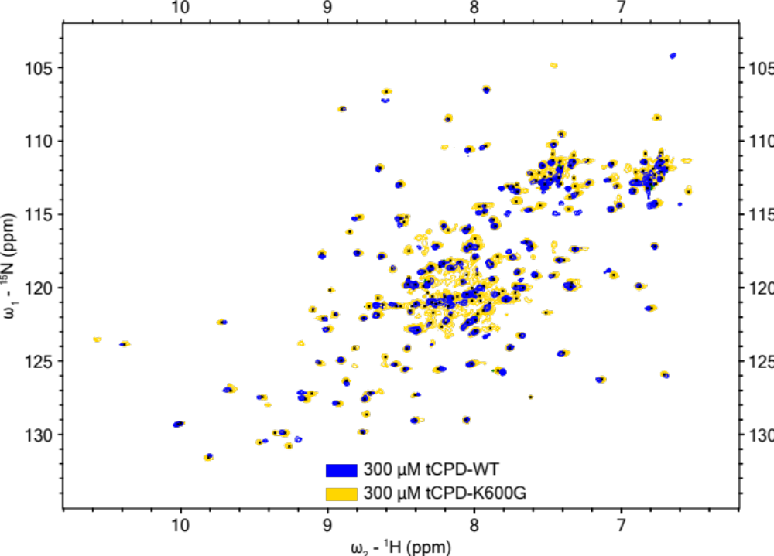
Figure 3. Two overlapping ¹H-¹⁵N-HSQC NMR spectra generated from 300 μM of tCPD-WT (peaks shown in blue) or 300 μM of tCPD-K600G (peaks shown in yellow). The HSQC spectra for tCPD-WT showed the appearance of 153 well resolved peaks and tCPD-K600G showed 218 peaks.

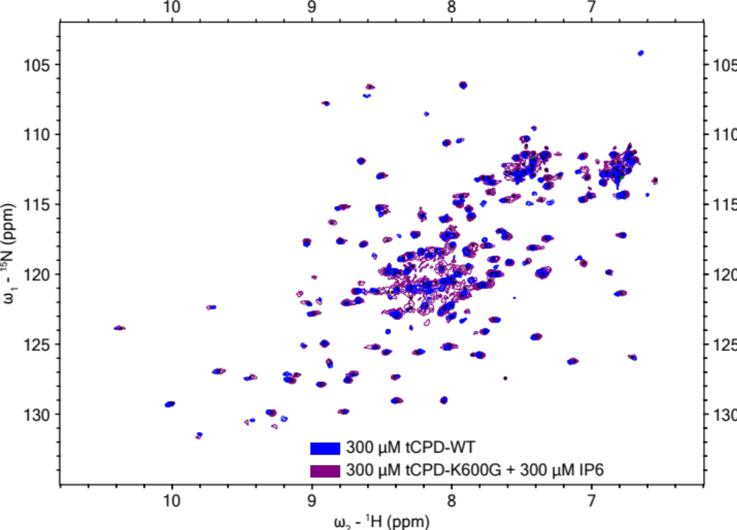
Figure 4. Two overlapping ¹H-¹⁵N-HSQC NMR spectra generated from 300 μM of tCPD-WT (peaks shown in blue) or 300 μM of tCPD-K600G bound to a molar equivalent of IP6 (300 μM, peaks shown in purple). The HSQC spectra for tCPD-WT showed the appearance of 153 well resolved peaks and when tCPD-K600G bound to IP6 173 peaks were apparent.

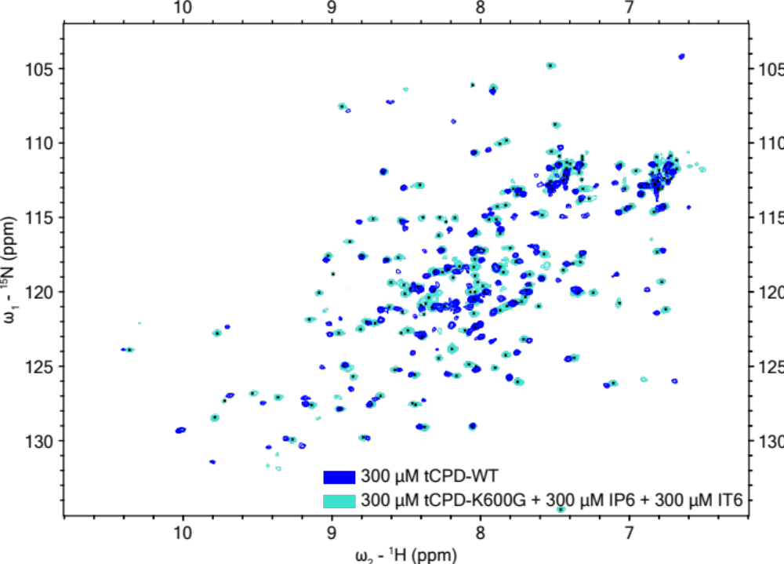
Figure 5. Two overlapping ¹H-¹⁵N-HSQC NMR spectra generated from 300 μM of tCPD-WT (peaks shown in blue) or 300 μM of tCPD-K600G in the presence of a molar equivalent of IP6 and IT6 (300 μM each, peaks shown in turquoise). The HSQC spectra for tCPD-WT showed the appearance of 153 well resolved peaks and when tCPD-K600G bound to IT6 182 peaks were apparent.

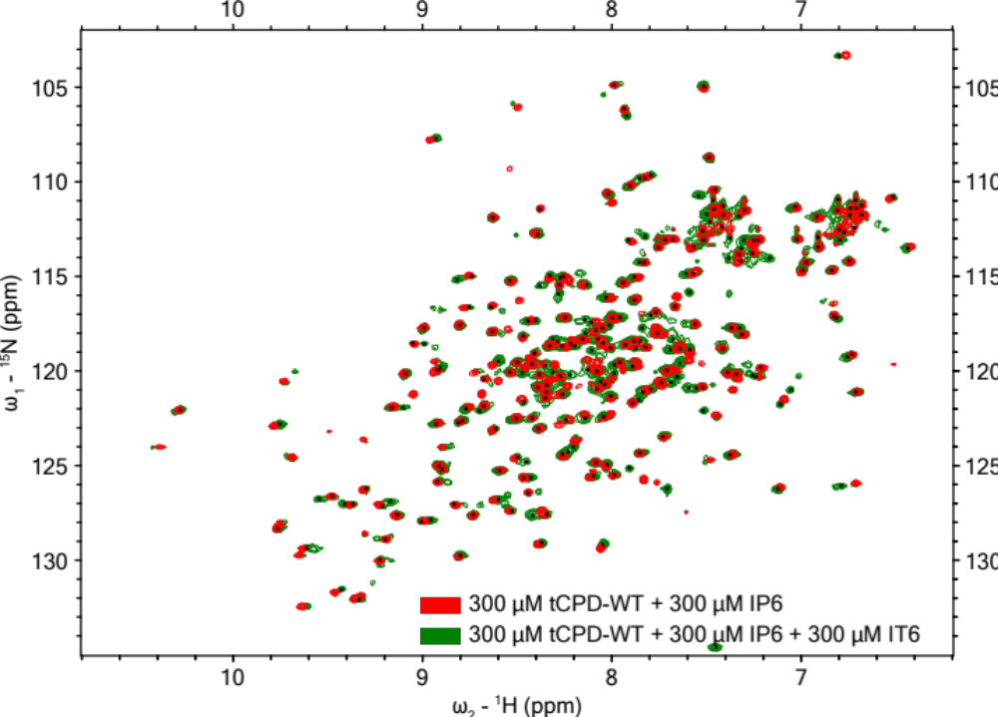
Figure 6. Two overlapping ¹H-¹⁵N-HSQC NMR spectra generated from 300 μM of tCPD-WT bound to a molar equivalent of IP6 (300 μM, peaks shown in red) or 300 μM of tCPD-WT in the presence of a molar equivalent of IP6 and IT6 (300 μM each, peaks shown in green). The HSQC spectra for tCPD-WT bound to IP6 showed the appearance of 240 well resolved peaks and when tCPD-K600G bound to IT6 257 peaks were apparent.

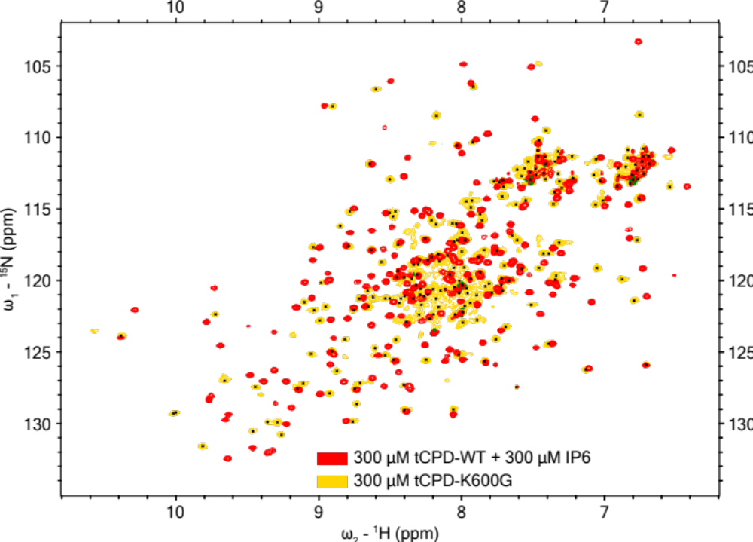
Figure 7. Two overlapping ¹H-¹⁵N-HSQC NMR spectra generated from 300 μM of tCPD-WT bound to a molar equivalent of IP6 (300 μM, peaks shown in red) or 300 μM of tCPD-K600G (peaks shown in yellow). The HSQC spectra for tCPD-WT bound to IP6 showed the appearance of 240 well resolved peaks and tCPD-K600G showed 218 peaks.

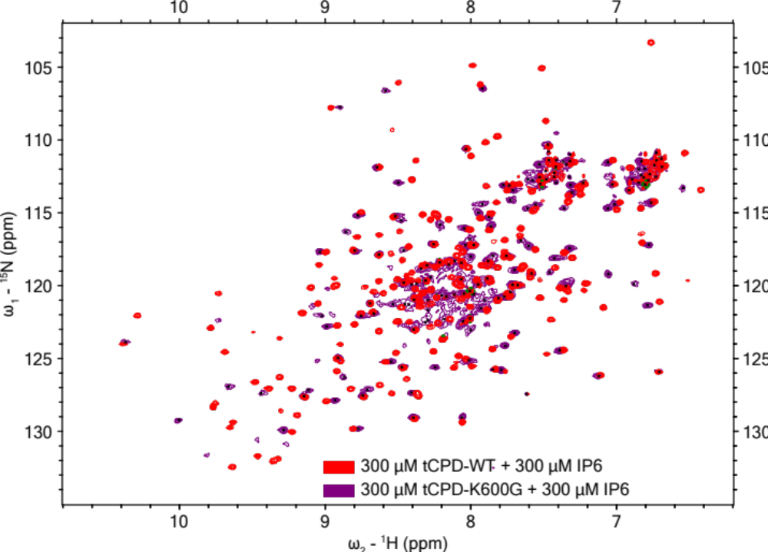
Figure 8. Two overlapping ¹H-¹⁵N-HSQC NMR spectra generated from 300 μM of tCPD-WT bound to a molar equivalent of IP6 (300 μM, peaks shown in red) or 300 μM of tCPD-K600G bound to a molar equivalent of IP6 (300 μM, peaks shown in purple). The HSQC spectra for tCPD-WT bound to IP6 showed the appearance of 240 well resolved peaks and when tCPD-K600G bound to IP6 173 peaks were apparent.

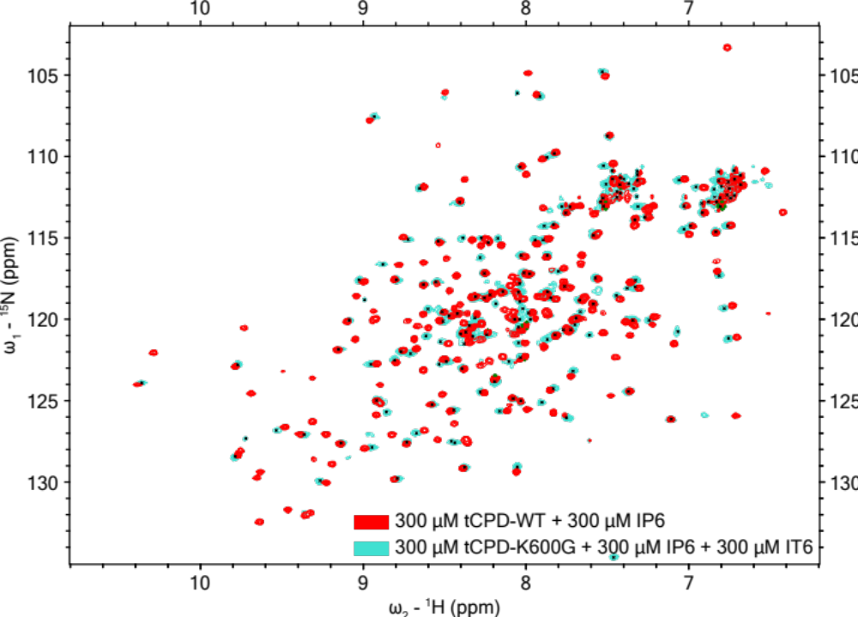
Figure 9. Two overlapping ¹H-¹⁵N-HSQC NMR spectra generated from 300 μM of tCPD-WT bound to a molar equivalent of IP6 (300 μM, peaks shown in red) or 300 μM of tCPD-K600G in the presence of a molar equivalent of IP6 and IT6 (300 μM each, peaks shown in turquoise). The HSQC spectra for tCPD-WT bound to IP6 showed the appearance of 240 well resolved peaks and when tCPD-K600G bound to IT6 182 peaks were apparent.

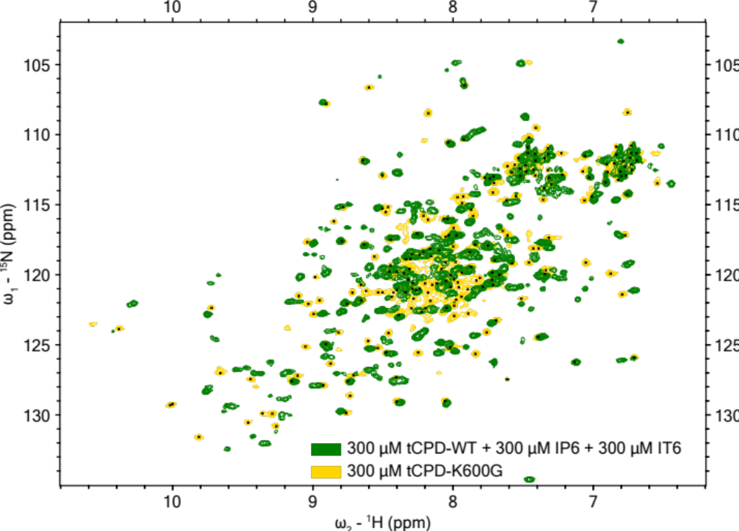
Figure 10. Two overlapping ¹H-¹⁵N-HSQC NMR spectra generated from 300 μM of tCPD-WT in the presence of a molar equivalent of IP6 and IT6 (300 μM each, peaks shown in green) or 300 μM of tCPD-K600G (peaks shown in yellow). The HSQC spectra for tCPD-K600G bound to IT6 showed the appearance of 257 well resolved peaks and tCPD-K600G showed 218 peaks.

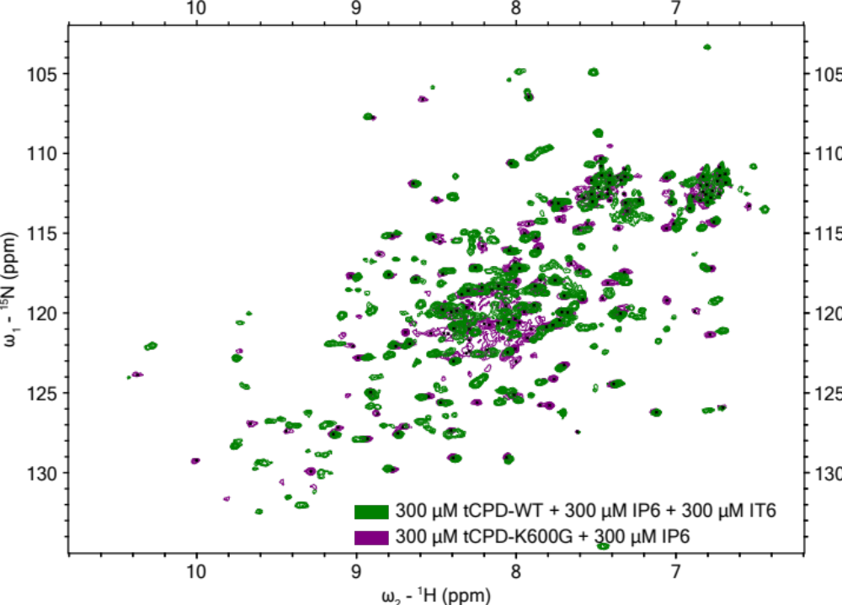
Figure 11. Two overlapping ¹H-¹⁵N-HSQC NMR spectra generated from 300 μM of tCPD-WT in the presence of a molar equivalent of IP6 and IT6 (300 μM each, peaks shown in green) or 300 μM of tCPD-K600G bound to a molar equivalent of IP6 (300 μM, peaks shown in purple). The HSQC spectra for tCPD-K600G bound to IT6 showed the appearance of 257 well resolved peaks and when tCPD-K600G bound to IP6 173 peaks were apparent.

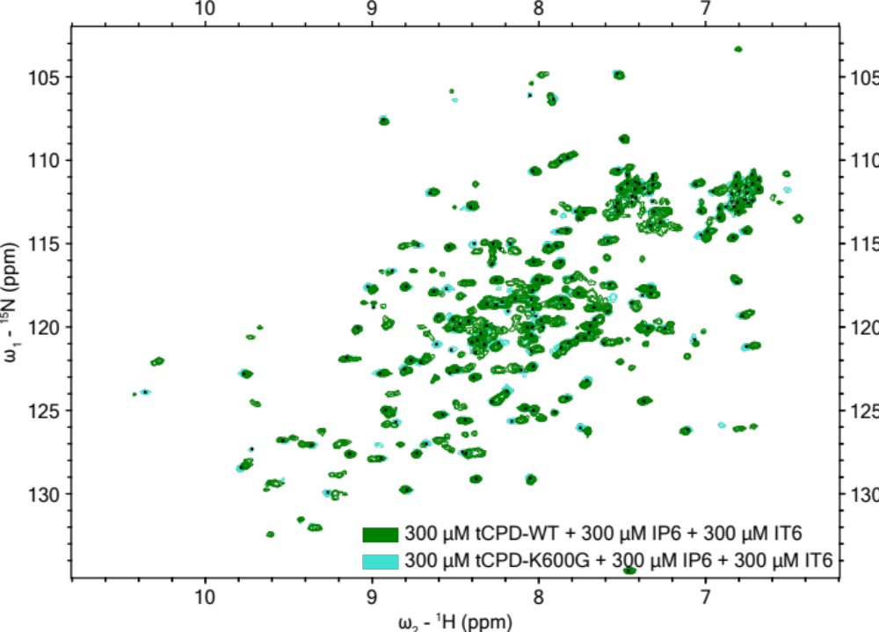
Figure 12. Two overlapping ¹H-¹⁵N-HSQC NMR spectra generated from 300 μM of tCPD-WT in the presence of a molar equivalent of IP6 and IT6 (300 μM each, peaks shown in green) or 300 μM of tCPD-K600G in the presence of a molar equivalent of IP6 and IT6 (300 μM each, peaks shown in turquoise). The HSQC spectra for tCPD-K600G bound to IT6 showed the appearance of 257 well resolved peaks and when tCPD-K600G bound to IT6 182 peaks were apparent.

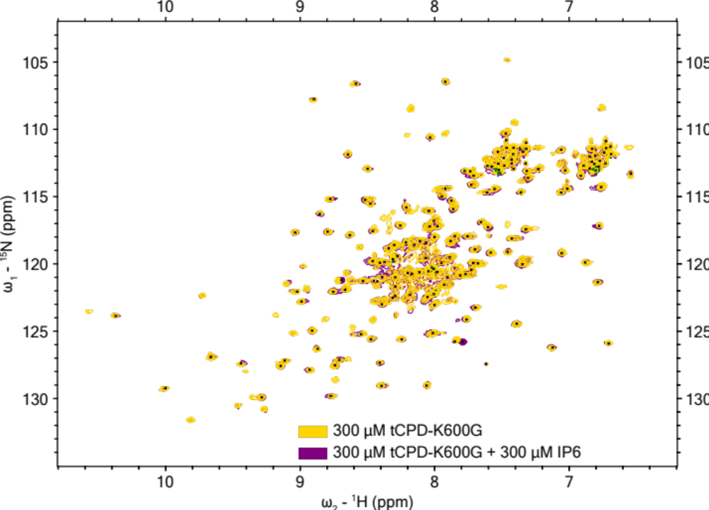
Figure 13. Two overlapping ¹H-¹⁵N-HSQC NMR spectra generated from 300 μM of tCPD-K600G (peaks shown in yellow) or 300 μM of tCPD-K600G bound to a molar equivalent of IP6 (300 μM, peaks shown in purple). The HSQC spectra for tCPD-K600G showed the appearance of 218 peaks and when tCPD-K600G bound to IP6 173 peaks were apparent.

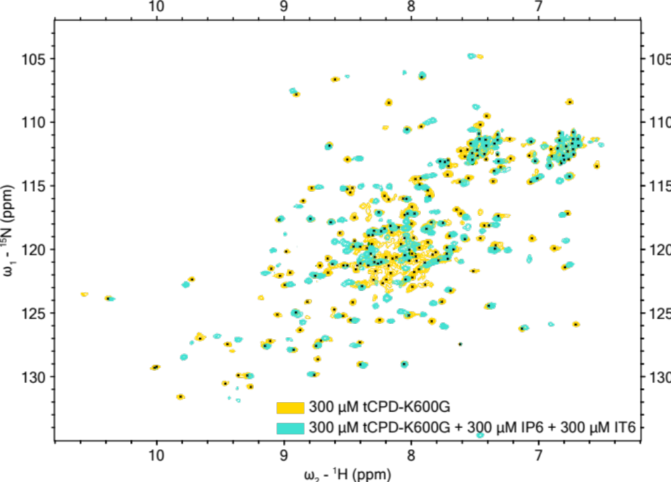
Figure 14. Two overlapping ¹H-¹⁵N-HSQC NMR spectra generated from 300 μM of tCPD-K600G (peaks shown in yellow) or 300 μM of tCPD-K600G in the presence of a molar equivalent of IP6 and IT6 (300 μM each, peaks shown in turquoise). The HSQC spectra for tCPD-K600G showed the appearance of 218 peaks and when tCPD-K600G bound to IT6 182 peaks were apparent.

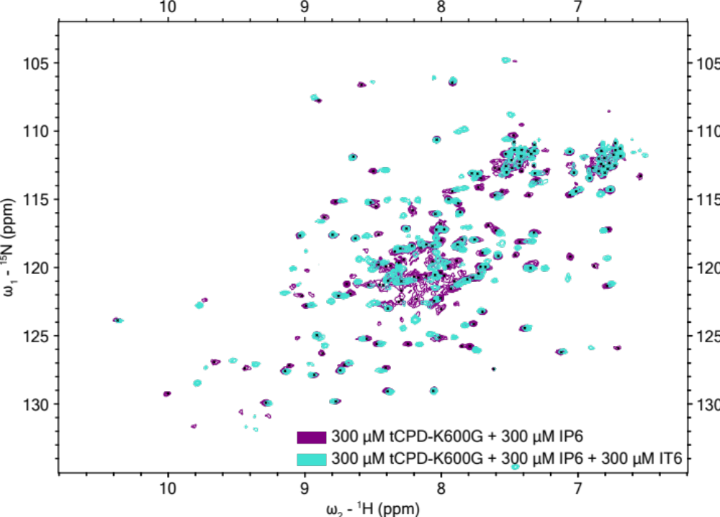
Figure 15. Two overlapping ¹H-¹⁵N-HSQC NMR spectra generated from 300 μM of tCPD-K600G bound to a molar equivalent of IP6 (300 μM, peaks shown in purple) or 300 μM of tCPD-K600G in the presence of a molar equivalent of IP6 and IT6 (300 μM each, peaks shown in turquoise). The HSQC spectra for tCPD-K600G bound to IP6 showed the appearance of 173 peaks and when tCPD-K600G was bound to IT6 182 peaks were apparent.

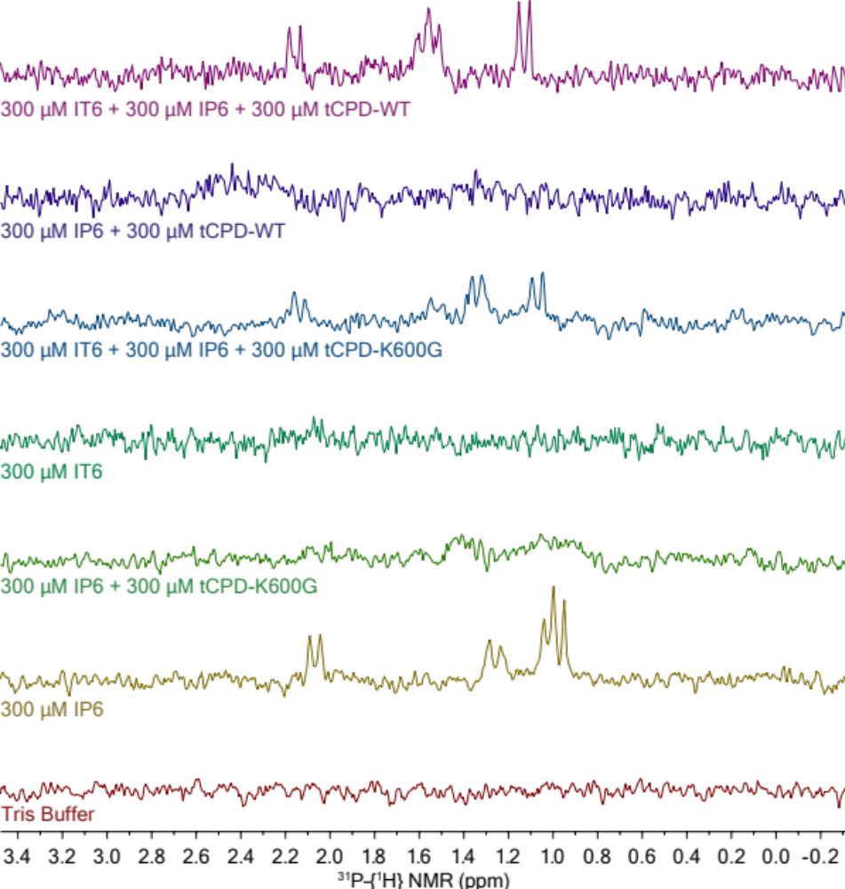
Figure 16. Stacked phosphorus NMR spectra (³¹P with ¹H coupling) of the samples from the competition assay where one molar equivalent of both IT6 and IP6 were added to tCPD-WT and tCPD-K600G. For both tCPD-WT and tCPD-K600G, IP6 is displaced by IT6 when 300 $μ$M of IT6 was added to the tCPD bound to a molar equivalent of IP6.

